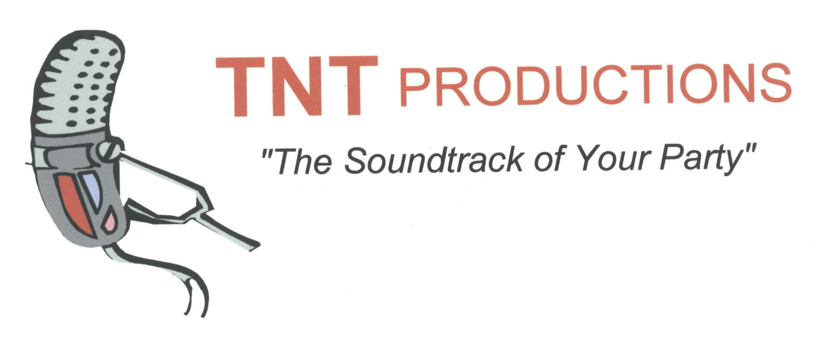
(574) 276-1533

TNT Productions agrees to provide ___________________________ with up to _____

hours of dance music from________ to _________ on ___/ ___/___. The fee for this

service will be $ ________.

A deposit of $ ______ is required to hold the date. If CLIENT cancels within 90 days of the event, this deposit will not be refunded. The balance due must be paid on the event date before performance begins.
The DJ will arrive at approximately ____:____ to begin setting up at the following location:

Please note that the DJ will need a table provided for his use. In the case of inclement or pending
inclement weather, the DJ will also need some sort of shelter if the event is to be held outdoors.

If DJ fails to perform as scheduled due to circumstances beyond the control of TNT Productions (i.e. illness, accident, theft or vandalism of equipment, Act of God or nature) the deposit will be refunded in full and TNT Productions and the DJ will not be held further accountable.
______ (initials)

Dinner music IS ______ IS NOT ______ included in the package quoted above.

Client's Name:

___________________________________________________________________________

Address:

___________________________________________________________________________

City/State/Zip

_____________________________________________________________________

Home phone ____ - _____ - ______ Work phone ________ - ________ - _________

Expected number of guests: ___________

I agree to the terms of this contract:

___________________________________________________Date: __________________
Client

___________________________________________________Date:___________________
Agent, TNT Productions

